TSDS Parallel Descriptor Mapping

Descriptor Mapping is a functionality within the DMC that allows an LEA to map non-TEDS defined descriptor values loaded in the IODS to TEA descriptor values for reporting to TSDS. LEAs will need to check with their software vendor to see if TSDS descriptor mapping will be done within the software or if the LEA will have to map the descriptors in TSDS.

- Log into TEAL.
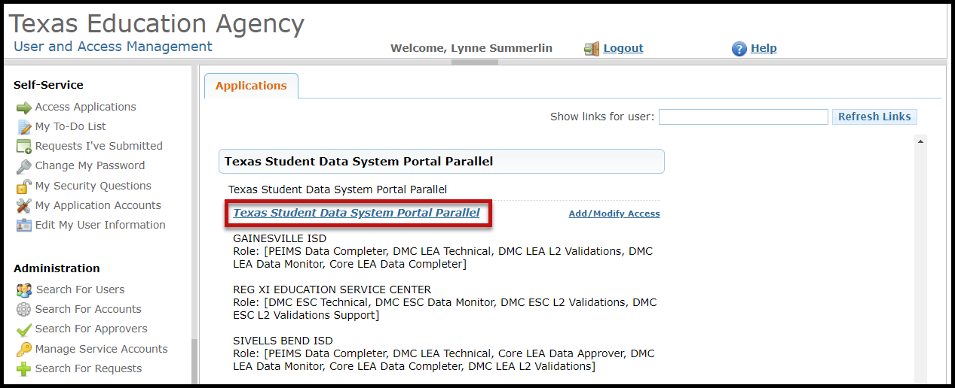
- Click on Texas Student Data System Portal Parallel link.

- Click on DMC or Manage IODS.

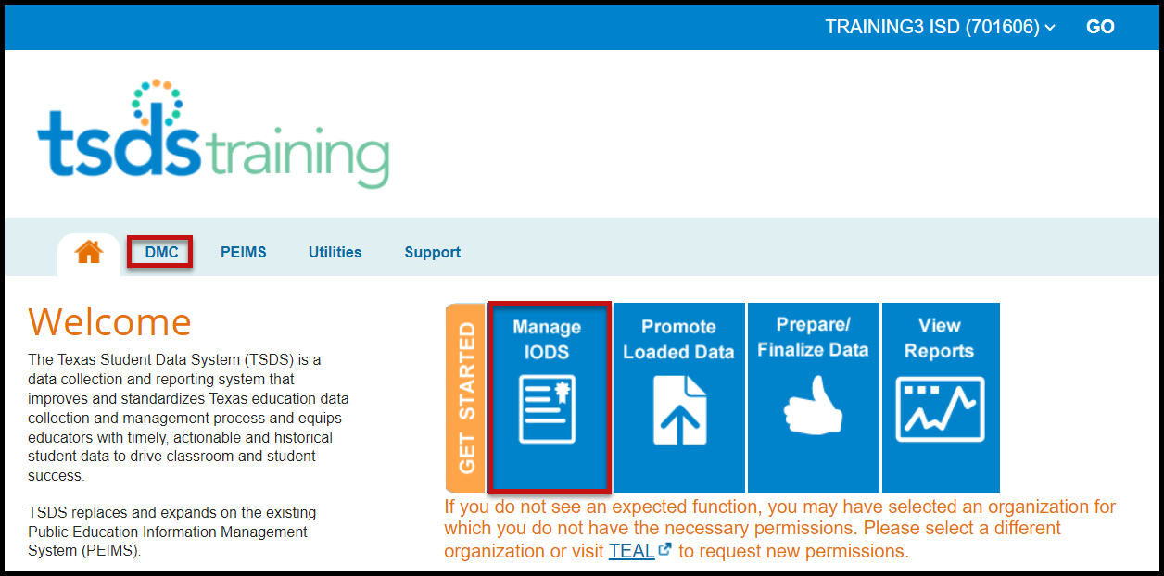

- Under Admin, click Map Descriptors.
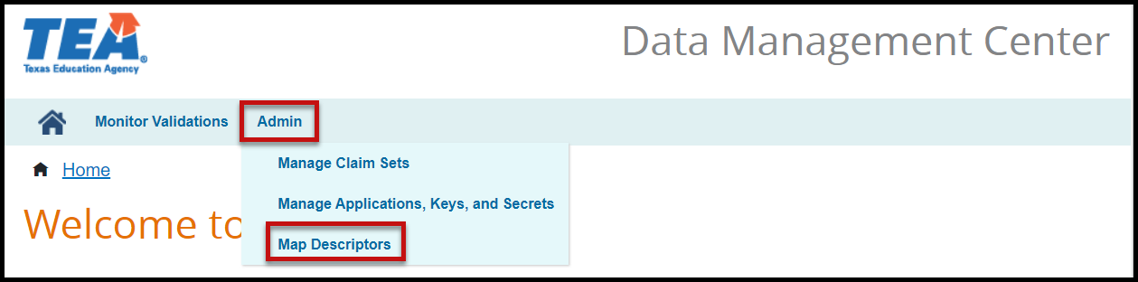

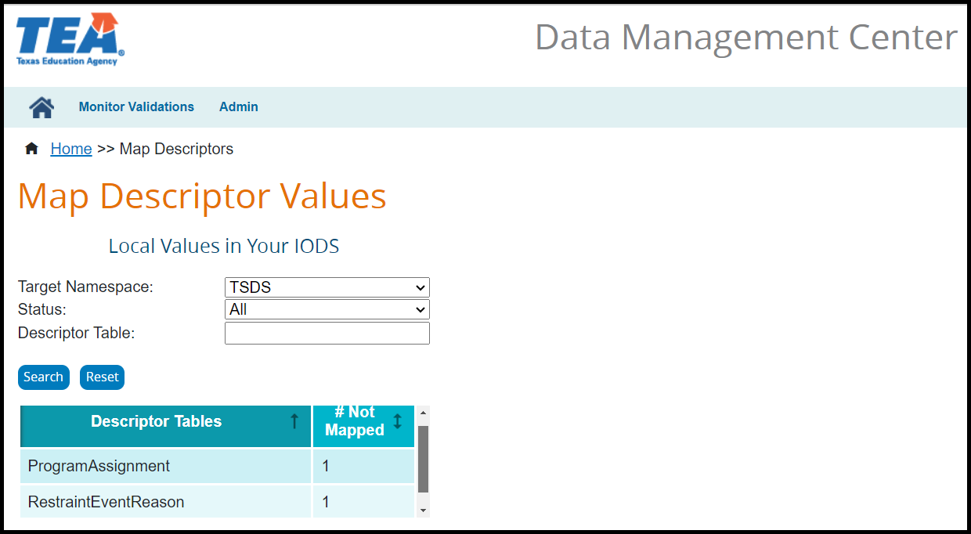

- Select the appropriate Status from the pulldown menu.

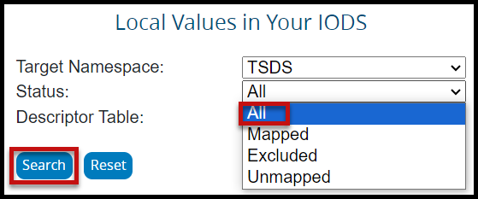

- Click on the Descriptor Table to be mapped.

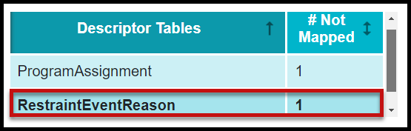

- The Local Values (from LEA Data) and Outgoing Values (TSDS Value) fields appear:

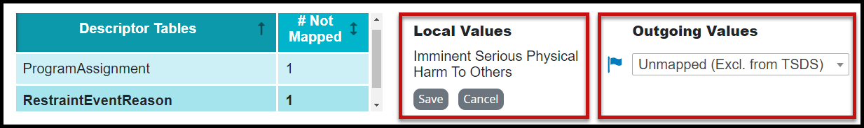

- From the pulldown menu select the appropriate Outgoing Value.
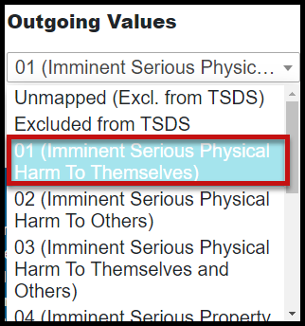

TSDS Descriptor Values – TEDS compliant values are available to map for TSDS State Reporting. The Local Value will remain in the IODS and the mapped Outgoing Value will move to the Transition Zone for reporting.

Unmapped (Excl. fromTSDS) – Value will be excluded from TSDS State Reporting.

Excluded From TSDS – Original descriptor value will remain in the Landing Zone for local use and will continue to appear in the L1.5 Filter as mapped.

- Click Save to save the mapping selection. Click Save in the popup message to confirm.
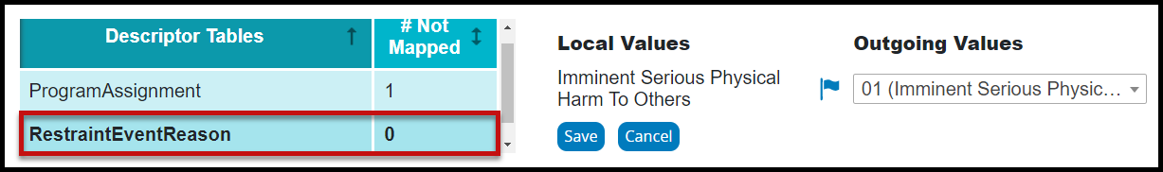
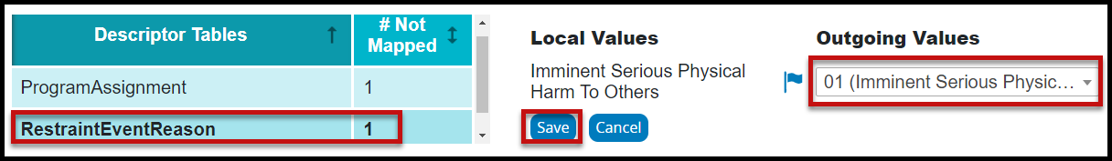

- Descriptor Mapping may need to be reviewed and updated as the LEA begins working on the different submissions or collections.

